**Counting of Days**

**Description**

* The module is made to find Number of Days (Mon, Tue, Wed etc.) occurring in between two dates selected by two users.
* The idea is implemented by integrating JAVA code with Mendix.
* The entire logical part is written in Java code.

**Typical Usage Scenario**

There is a case where we are required to find the no. of Days between two selected dates by the user then this component can be used to get the expected output.

**PreRequisites**

NA

**Features and Limitations**

The Java Action will give the output in integer variable which can be used for further logic development and the output will be string. The Dates will be comma separated values which can be extracted by using split java action

**Dependencies**

Require Mendix 9.18 or above.

**Installation**

1. Download the Module from marketplace.

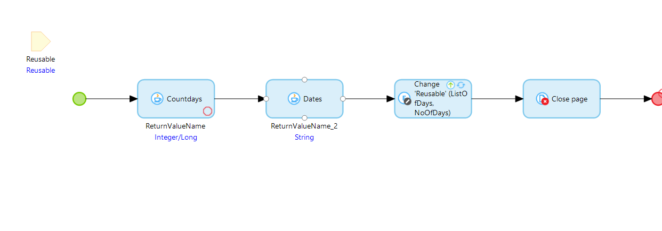

1. The Java Action requires 3 Parameters.
2. Start Date
3. End Date
4. Day

* Start Date and End Date will be in Date Time format and Day in 3 letter string.
* IT will give a valid output only if the Day attribute will contain first three letters of the day.

Ex. (Mon, Tue, Wed etc.)

* The Countdays Java action will return No of days in Integer format.

* The Dates Java action will return List of days append with (;) in string format.

* The expected output will look like the columns below.

**Configuration: NA**

**Category: Module**

**Subcategory: All**

**Visibility: Public Marketplace**

**Studio Pro Version: 9.18.0**